101. Ms. Durkin asked for volunteers to help
- with the employee fitness program.

(A) she (B) her
- hers
- herself
102. Lasner Electronics' staff have extensive of current hardware systems.
- know
- known
- knowledge
- knowledgeable
103 a year, Tarrin Industrial Supply audits the accounts of all of its factories.
- Once
- Immediately
- Directly
- Yet
104. Ms. Pham requested a refund the coffeemaker she received was damaged.
- despite
- why
- concerning
- because
105.
106.
107.
108.
READING TEST
In the Reading test, you will read a variety of texts and answer several different types of reading comprehension questions. The entire Reading test will last 75 minutes. There are three parts, and directions are given for each part. You are encouraged to answer as many questions as possible within the time allowed.
You must mark your answers on the separate answer sheet. Do not write your answers in your test book.
PART 5
Directions: A word or phrase is missing in each of the sentences below. Four answer choices are given below each sentence. Select the best answer to complete the sentence. Then mark the letter (A), (B), (C), or (D) on your answer sheet.
Information the artwork in the lobby is available at the reception desk.
- across
- about
- upon
- except
With the Gema XTl binoculars, users can see objects that are more than 100 meters away.
- ease
- easy
- easily
- easier
The Physical Therapy Association is committed to keeping costs for its certification programs.
- affordable
- permitted
- cutting
- necessary
Mr. Brennel positions in various areas of the company before he became president.
- occupational
- occupying
- occupied
(A) occupation
- To remain on schedule, editors must submit all to the book to the authors by Friday.
  - ideas
  - essays
  - revisions
  - suggestions
- ------- industry professionals are allowed to purchase tickets to the Kuo Photography Fair.
  - Only
  - Until
  - Unless
  - Quite
- At Pharmbeck's banquet, Mr. Jones a trophy for his performance in this year's quality-improvement initiative.
  - accepted
  - congratulated
  - nominated
  - hoped
- Ms. Suto claims that important market trends become ------- with the use of data analysis.
  - predict
  - prediction
  - predictable
  - predictably
- One of Grommer Consulting's goals is to enhance the relationship ------- salespeople and their customers.
  - inside
  - within
  - around
  - between
Depending on your answers to the survey, we you to collect additional information.
  - may call
  - are calling
  - have been called
  - must be calling
115.
116.
117.
118.
119.
120.
Jemburger opened its newest franchise, the first 100 customers were given free hamburgers. (A) Now
(B) When

(C) As if
(D) After all
Please include the serial number of your product in any with the customer service department. (A) corresponds
- correspondence
- correspondingly
- correspondent
The award-winning film Underwater Secrets promotes awareness ocean pollution and its effects on our planet. (A) of
- from
- with
BY F Company specializes in promotional items to help companies advertise their brand.
- personally
- personalized
- personality
- personalizes
- the rent increase is less than 2 percent, Selwin Electrical Supply will continue to lease the space.
- As long as
- Along with
- Not only
- Otherwise
Belden Hospital's chief of staff meets regularly with the staff to ensure that procedures ------- correctly. (A) to be performed
- would have performed
- had been performed
- are being performed

- Any requests for time off should be addressed to the department supervisor.
  - urgent
  - appropriate
  - subsequent
  - deliverable
- World Fish Supply delivers the freshest fish possible thanks to innovative and shipping methods.
  - preserves
  - preserved
  - preserve
  - preservation
- Company executives are currently reviewing the annual budget submitted to them by the Financial Planning department.
  - requirements
  - deliveries
  - developers
  - qualities
- Even the CEO had to admit that Prasma Designs' win was the result of fortunate timing. (A) parts
  - parted
  - partly
  - parting
- Mr. Singh took notes on the focus group discussed during the morning session. (A) each
  - several
  - another
  - everything
- Last year, Tadaka Computer Solutions ranked third in regional earnings.
  - together
  - overall
  - consecutively
  - generally
- - the popularity of the BPT39 wireless speaker, production will be increased fivefold starting next month.
  - On behalf of
  - Whether
  - Moreover
  - As a result of
- Zypo Properties has just signed a lease agreement with the law firm offices are on the third floor. (A) how
  - what
  - whose
  - wherever
- events this year caused profits in the second and third quarters to differ significantly from original projections.
  - Total
  - Marginal
  - Representative
  - Unforeseen
- The timeline for the pathway lighting project was extended to input from the environmental commission.
  - use up
  - believe in
  - make into
  - allow for
PART 6
Directions: Read the texts that follow. A word, phrase, or sentence is missing in parts of each text. Four answer choices for each question are given below the text. Select the best answer to complete the text. Then mark the letter (A), (B), (C), or (D) on your answer sheet.
Questions 131-134 refer to the following advertisement.
With Global Strength Gym's 30-day trial period, you get the opportunity to try out our classes,
equipment, and facilities. - It's completely risk-free! To sign up, we require your contact iii.-
information and payment details, but you will only be charged if you are a member for
30 days. If you decide within this time that you no longer want to be a member of 132.
Global Strength, ----- - visit our Web site at www.gsgym.com. On the Membership page, elect to 13i.
your membership and enter the necessary information. It's that easy! 134.

- (A) Throughout the trial, you pay nothing and sign no contract.
  - Weight-lifting classes are not currently available.
  - A cash deposit is required when you sign up for membership.
  - All questions should be e-mailed to customerservice@gsgym.com.
- (A) not even
  - almost
  - over

(D) less than
- (A) justly
    - regularly
    - evenly
    - simply
- (A) extend
    - renew
    - cancel
    - initiate

135-138 instructions.
As a Hanson-Roves employee, you are entitled to sick absences, during which you will be paid for
time off work for health - To avoid deductions to your pay, you to provide a
iiä.- 136. physician-signed note as documentation of your illness. should include the date you were 137.
seen by the doctor, a statement certifying that you are unable to perform the duties of your position, and your expected date of return. Your supervisor will then forward the documentation to
Human Resources. - Employee health records can be accessed only by those with a valid
iiä.-
business reason for reviewing them.

- (A) reasons
    - origins
    - senses
    - contributions
- (A) were required
    - require
    - are required
    - are requiring
- (A) Those
(B) They
- (A) Hanson-Roves ensures the privacy of your health information.
    - Absences may be caused by a number of factors.
    - You should then explain why a physician's note is not available.
    - Take note of the duties you were originally assigned.
Questions 139-142 refer to the following e-mail.
To: fcontini@attmail.com
From: btakemoto@arolischems.co.uk
Date: 15 July
Subject: Your first day at Arolis
Dear Mr. Contini,
Welcome to Arolis Chemicals! Thank you for ------- the full-time, permanent position of laboratory 139.
assistant. We look forward to your arrival on 1 August in the Harris Building. Please report to the
front desk and ask for Jack McNolan. He you to the Human Resources office. There, you 140. will obtain your employee badge ------- all documents necessary to start work. Note that because 141.
of its large size, the Leicester campus of Arolis can be difficult to navigate. Studying a campus
map will help orient you to the location of the different buildings.
142.
Should you have any questions, please do not hesitate to contact me.
Sincerely,
Brandon Takemoto
HR Administrative Officer

- (A) offering
    - accepting
    - discussing
    - advertising
- (A) accompany
    - did accompany
    - accompanies
    - will accompany
- (A) too
    - also
    - as well as
    - additionally
- (A) Please sign all the documents. (B) I will provide you with a replacement.
    - Construction will be completed next year.
    - You can download one from our Web site.

143-146 article.
(18 April)—MKZ Foods, Inc., the region's largest exporter of pecans, expects its outgoing
shipments to increase significantly over the next few months. This - is based on the fact that i43.
the region's pecan farmers expanded their land area by 20 percent last year. According to spokesperson Katharina Seiler, MKZ's exports could reach a colossal 50,000 metric tons this year. -
MKZ buys most of the yield from the region's pecan farms and processes it - - --- export iä5.
throughout the world. "The availability of new land for in the region is creating opportunities 146.
for growth," said Ms. Seiler. "l believe MKZ is going to have a truly outstanding year."
143. (A) cost |  | 145. (A) on
(B) delay |  | (B) for
(C) decision |  | (C) in
(D) forecast |  | (D) by
144. (A) Such a figure is unprecedented in the |  | 146. (A) farming
company's history. |  | (B) farmer
(B) Moreover, Ms. Seiler holds an |  | (C) farmed
advanced degree in economics.  - Pecans are high in vitamins and minerals.  - Still, MKZ shares have been profitable in recent years. |  | (D) farm
PART 7
Directions: In this part you will read a selection of texts, such as magazine and newspaper articles, e-mails, and instant messages. Each text or set of texts is followed by several questions. Select the best answer for each question and mark the letter (A), (B), (C), or (D) on your answer sheet.
Questions 147-148 refer to the following text message.
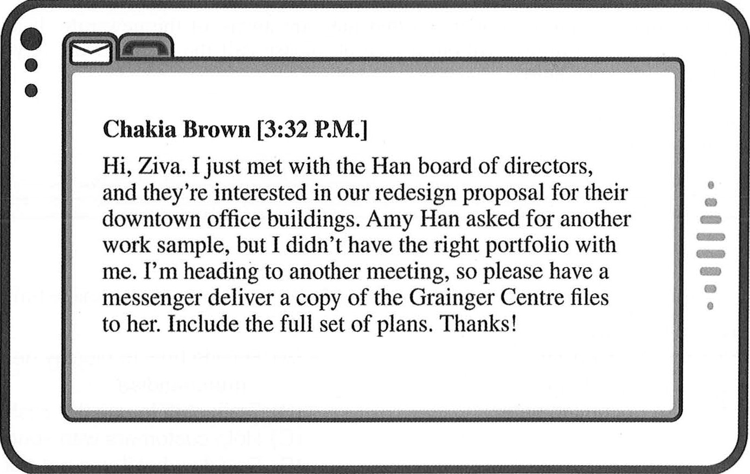

- Where does Ms. Brown most likely work?
    - At an accounting firm
    - At an architectural firm
    - At a Web design company
    - At a market research company
- What is Ziva asked to do? (A) Reply to a text message
    - Create a portfolio
    - Set up a meeting
    - Send a work sample
- What is the purpose of the e-mail?
    - To request a sales report
    - To announce a new policy
    - To discuss a fashion trend
    - To describe an upcoming sale
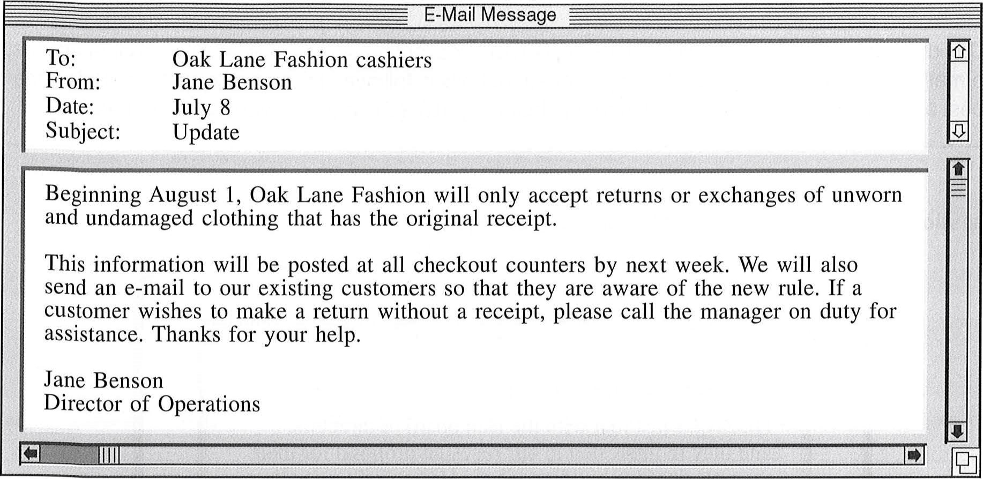
- According to the e-mail, what will managers
149-150
e-mail.
  - Decide how to display new merchandise
  - Train staff to use the cash register

  - Help customers with special requests
  - Decide what items get price discounts

Web page.
 | https://www.carmontmedia.co.tt | 
Carmont Media's Culture
Home | 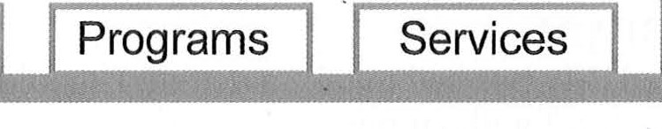  Media, our work culture is mission common goal of enriching listeners' minds  We also actively recruit a diverse staff audiences. Carmont Media's diversity composed of workers from all levels hold brainstorming sessions aimed at  Carmont Media offers opportunities work-life balance. |   driven. We hire through engaging to reflect our contributes to of the organization, improving efficiency for professional | people  its | Contact Us
stories.  teams, to encourages |  |  | people  its | who and truthful Trinidadian and Star teams. meet and advancement
  At Carmont share a news Tobagonian These regularly productivity. and

- What is mentioned about Carmont Media's 152. What is a purpose of Carmont Media's Star employees? teams?
    - They get experience in various (A) Seeking new employees departments. (B) Raising funds for projects
    - They enjoy working for the (C) Promoting work-life balance organization. (D) Finding creative solutions
    - They come from a variety of backgrounds.
    - They are recruited through a staffing agency.
text-message chain.
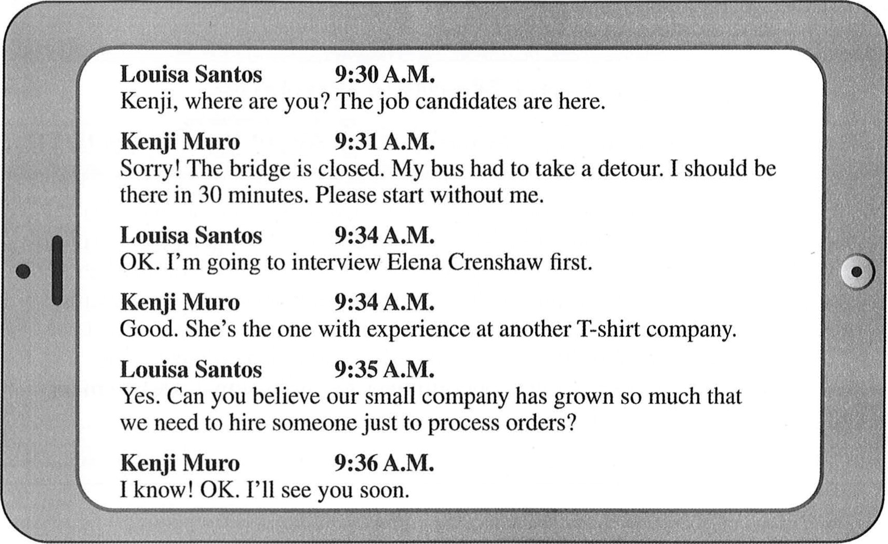

- What does Mr. Muro want Ms. Santos to do?
    - Process some orders
    - Make a hiring decision
    - Reschedule a meeting
    - Talk to a job candidate
- At 9:36 A.M., what does Mr. Muro mean when he writes, "l know"?
    - He is also surprised by the company's growth.
    - He thinks salaries should be higher.
    - He has met Ms. Crenshaw before. (D) He is certain his bus will arrive in 30 minutes.
article from a company newsletter.
Mark Chandler is Back!

The Administrative Services Division welcomes back to headquarters Associate Director Mark Chandler. [^{l}] Mark spent the last month in Ottawa attending an advanced training session about corporate information security. Corporate-security training allows a company to safeguard its sensitive, confidential, and proprietary information.
Mark is among a growing number of corporate executives who have successfully graduated from this rigorous course. [2] member of the National Organization of Corporate Security Officers (NOCSO), Mark was formally recognized by the organization for his part in developing software that keeps electronic documents safe. [³1 . Well done, Mark! 

- What is the purpose of the article?
    - To recognize an employee's accomplishments
    - To introduce a new staff member
    - To clarify what information is considered confidential
    - To describe the challenges of corporate security
- How did Mr. Chandler improve corporate security?
    - He trained his company's security officers.
    - He helped design a system for securely storing documents.
    - He assisted in developing new safety guidelines.
    - He recruited employees who specialize in corporate security.
- In which of the positions marked [1], [2], [3], and [4] does the following sentence best belong?
"The training included 60 hours of instruction and a comprehensive written exam."
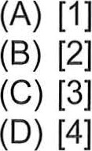

158-160 card.
Congratulations on purchasing Megagroome, the world's finest rechargeable shaver! To keep your shaver in top condition, clean your shaver weekly by running it under hot water. Once a month, disassemble the shaver and clean the internal portion thoroughly as shown in the owner's manual. The shaving heads should be replaced every year with the replacement parts listed in the manual.
The Megagroome shaver has a lithium ion battery that should last for several years. Please charge the shaver as often as needed. It is not necessary to fully discharge the battery before recharging it. Use only the included charger, because use of any other charger may void the warranty. Complete instructions and details can be
found in the owner's manual.

aegagroome

- Where would the card most likely be found? (A) Inside a box with a product
    - On a bulletin board
    - In a product display at a store
    - In the pages of a magazine
- How often should the shaver be taken apart? (A) Daily
    - Weekly
    - Monthly
    - Annually
- What is indicated about the shaver's battery?
    - It must run out before charging.
    - It may be charged whenever
necessary.
    - It is able to hold a charge for a week.
    - It will work with different chargers.
161-163 Web page.

DIVERSIFY MUSEUM
A Museum of Cross-Cultural History and Artifacts
We are proud to announce our newest exhibit: South American Art.
The exhibit will open on 7 June as part of the museum's ongoing Arts Around the World programme. All museum patrons who have paid the museum entrance fee may view the exhibit. It will feature historical and contemporary artwork displays from renowned South American artists.
The curator of the six-week exhibition, Julio Carrera, will bring his vast expertise to the museum. Before joining the museum's management in March of this year, Mr. Carrera was the curator for the Brazilian Institute of the Arts for six years and spent three years studying ancient artifacts for the Centro de la Historia del Arte, an art preservation centre in Venezuela.
The South American Art exhibit will include paintings, sculptures, crafting tools, clothing, jewellery, murals, and clay pottery from six South American countries. Visiting artists from these countries will provide art workshops on select dates in July. The cost for each workshop is CIO in addition to the regular admission fee and includes basic art supplies.

- What is indicated about the South American Art exhibit?
    - It is the first exhibit in the Arts Around the World program.
    - It will be on display only through the end of June.
    - It includes both old and new art.
    - It focuses on wall hangings and murals.
- Who is Mr. Carrera?
    - A visiting artist
    - An art journalist
    - A volunteer tour guide
    - A museum employee
- According to the Web page, what can museum patrons do for an extra fee?
    - Watch a video on South America
    - Attend an art class
    - Explore a new exhibit
    - Sponsor an upcoming exhibit
164-167 online chat discussion.
0--0-0
Oliver Koh (10:15 A.M.)
Hi, Aaron and Denise. Do you know if a package has arrived for me? I was supposed to get a delivery of some documents today, but maybe they were sent to someone else by mistake. It's from Schrantz Farm Organics and should be labeled urgent. Aaron Koskinen (10:17 A.M.)
There's nothing for you here at the front desk. You might want to check with the print shop on the ground floor.
Denise Matova (10:18 A.M.)
There's a package from Schrantz Farm Organics here in the mail room, but there's no name on it.
Oliver Koh (10:18 A.M.)
That must be the one for me. Could you please look at the delivery slip again?
Denise Matova (10:19 A.M.)
Sorry, it does have your name on it. It was so small I didn't notice it.
Oliver Koh (10:20 A.M.)
Great! Could you have the package sent up to my office please?
Denise Matova (10:20 A.M.)
No problem. I'm going upstairs in a minute anyway. Oliver Koh (10:21 A.M.) OK, thanks for your help.

- Why did Mr. Koh start the online chat discussion?
    - He received a damaged package.
    - He has a meeting with a client soon.
    - He is expecting some important documents.
    - He delivered a shipment to the wrong person.
- What does Mn Koskinen recommend doing?
    - Calling Schrantz Farm Organics
    - Changing a meeting place
    - Going to the front desk
    - Checking a different location
- At 10:19 A.M., what does Ms. Matova most likely mean when she writes, "Sorry"?
    - She misplaced a delivery slip.
    - She arrived late to work today.
    - She would like Mr. Koh to repeat his instructions.
    - She made a mistake reading a label.
- What will Ms. Matova probably do with the package?
    - Take it to Mr. Koh
    - Send it out by express mail
    - Leave it at the front desk
    - Remove the items from it
168-171 e-mail.
From: I  I | won Ho Kim
  Date:
  Subject:
 | Mana ement Team
 | 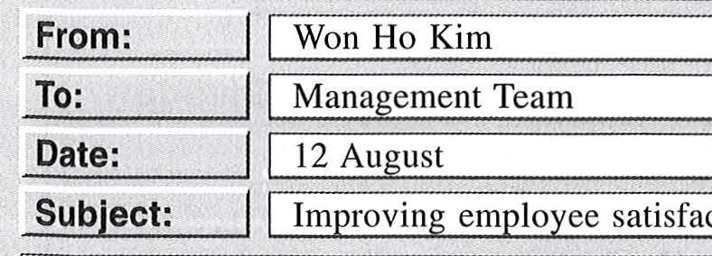
 | 1m rovin em 10 ee satisfaction
Management Team:
— [1] —. Over the next few months, the Human Resources department will be engaging with the Management Team in a variety of conversations about increasing productivity and employee satisfaction.
Telecommuting, in which employees are permitted to work from home all or part of the time, is an approach that many companies are using because it allows employees to work on tasks that may be difficult to complete in an omce full of disruptions. With the building reconfiguration project coming up in January, we would like to take the opportunity to consider whether telecommuting would be a good solution for our company. Our final decision on this matter will influence the way in which the work space is reorganized.
I am writing to ask for your feedback. [3] —. At this point, Human Resources is simply gathering information. Please complete the telecommuting survey, which is found on the Human Resources Web site. [4] — Just look for the link on the left side of the home page.
Thank you in advance, and please let me know if you have any questions.
Won Ho Kim
Human Resources Manager GHTY Engineering, Inc.

- Why was the e-mail sent? (A) To remind employees about a policy
    - To request participation in a survey
    - To discuss upcoming meetings
    - To encourage employees to attend an event
- What is mentioned as a benefit of telecommuting?
    - It helps employees work without interruptions.
    - It frees up space in the building for new workers.
    - It is good for the environment. (D) It saves the company money.
- What is the company planning to do in the new year?
    - Hire a new human resources manager
    - Reorganize the management team
    - Change the layout of its building
    - Introduce a new Web site
- In which of the positions marked [1], [2], [3], and [4] does the following sentence best belong?
"It should be noted that no decisions about telecommuting have been made."
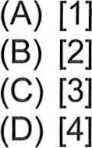
The Uppsala International Book Fair
22—24 September º Berglund Conference Hall º Uppsala, Sweden
Schedule for Friday, 22 September
Outthinking Public Opinion 12:00 noon-I:OO P.M., Salon A
Touring to promote his latest book, Outthinking Public Opinion, author Damian Schnauz makes a stop at the Uppsala International Book Fair to discuss his latest subject, take questions, and sign his books.
Introductory Course in Graphic Design P.M., Visual Media Centre
Professional digital designers Allen Doubek and Ivanette Lacasse will present useful techniques and provide attendees with hands-on practice opportunities.
Seminar on Online Publishing 3:00—4:30 P.M., Lindqvist Auditorium
Releasing and promoting e-books and audiobooks on the Internet. Speakers: Kenneth
Pulaski, editor-in-chief of Vendler Publishing, and Tina Savona, marketing manager at Vendler Publishing. All accompanying materials will be sold at the venue immediately before and after the seminar.
Readership in the Digital Age  P.M., Room 210 Is literacy promoted or inhibited by digital media? Debate moderated by Greg Gunnarson.
To attend these or any other sessions, purchase a daily admission ticket for 100 kr.
⁰ Note that reservations are not required for any session, but seating is limited, so please arrive a few minutes before the scheduled time to ensure a seat. Also note that while photos are permitted, no video recordings may be made of any presentation.
⁰ Meals are available for purchase at locations throughout Berglund Conference Hall.
Information about accommodations may be obtained on our Web site at uibf.se/hotels.

172-175 schedule of events.

- What is suggested about the first day of the Uppsala International Book Fair?
    - It is being organized by a team of publishers.
    - No sessions are scheduled for the morning hours.
    - Attendance is expected to be the highest on that day.
    - Mr. Schnauz will announce the subject of his next book.
- Where will book fair attendees be able to participate in interactive activities?
    - In Salon A
    - In the Visual Media Centre
    - In Lindqvist Auditorium
    - In Room 210
What is mentioned about the accompanying materials for the seminar?
    - They can be purchased on-site.
    - They can be downloaded online.
    - They are available in limited numbers.
    - They should be ordered from the presenters.
175. What are book fair attendees encouraged to do?
  - Ask questions after sessions
  - Post photos on social media
  - Rearrange seats as necessary
  - Arrive early for sessions

176-180 Web page e-mail.
http://www.mountainandforest.ca/custserv/shippinginfo
Clothing Gear Customer Service About Us

Mountain and Forest Company
The Leader in Quality Camping and Hiking Gear
Please note that most regular electronic or phone orders can be processed and made ready for shipping almost immediately. Custom and personalized orders may take up to five days for processing before they are shipped.
Please direct any questions or concerns to our customer service department at service@mountainandforest.ca. We will respond within 24 hours. Our shipping rates:
Order cost with tax Overnight shipping Express shipping Standard
(1 day) (3 days) (6-8 days)
Under $25 $8 $5 $3
$25 to $100 $13 $7 $5
Over $100 $18 $15 FREE
I recently placed an order for $135 for hiking boots and a thermal jacket intended for a camping trip this weekend. According to the confirmation I received at the time of my purchase, my order should have arrived yesterday. Since I paid an additional fee for three-day shipping, I was expecting that my order would arrive in a timely fashion. As it has not, I am requesting a refund of the shipping cost. Additionally, if my order has not been delivered by tomorrow, please cancel my order as I will have to purchase similar items at a local shop.
Sincerely,
Jin-Hee Shin
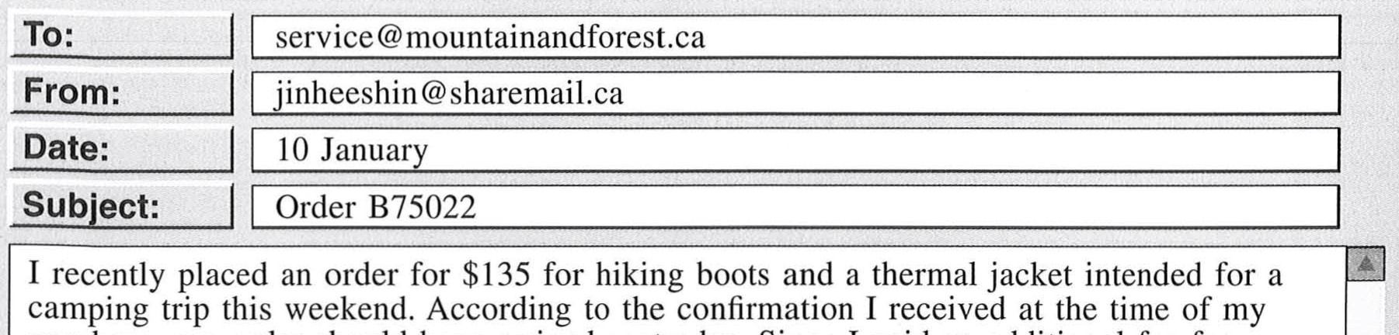

- In the Web page, what is indicated about Mountain and Forest's shipping?
  - Standard shipping is free for orders under $25.
  - Some shipped orders may take up to eight days to arrive.
  - The shipping cost depends on the total weight of an order.
  - Custom orders are not eligible for standard delivery.
- In the Web page, the word "direct" in paragraph 2, line 1, is closest in meaning to (A) address
  - supervise
  - prescribe
  - handle
- What is the purpose of the e-mail?
  - To suggest a new service policy
  - To inquire about an order packing error
  - To request a personalized item
  - To report a delivery problem
How much did Ms. Shin pay for shipping?
  - $15
  - $18
- According to the e-mail, why might Ms. Shin decide to visit a local shop?
    - She expects to purchase her items for a lower price.
    - She wants to support businesses in her town.
    - She needs to have her items before a certain date.
    - She hopes to find a greater selection of sportswear.
 | A umi Murakami <amurakami@sti.org>
 | 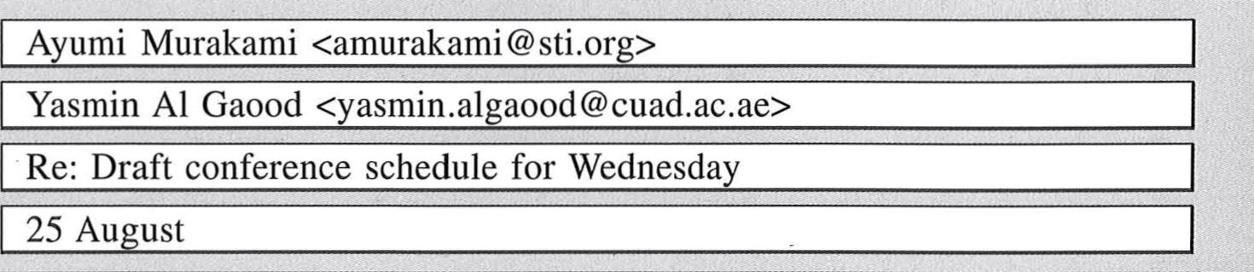
Date: | 25 Au ust
Hello, Yasmin,
As per your request, I have filled the slots that were listed as still available on the tentative conference schedule for Wednesday. Dr. Alban Buchanan in Scotland says that he is eager to talk about distance education as it is practiced within the film academies in his country. Also, my contact in Yaoundé wrote to let me know that Ms. Marie-Théröse Tchangou will be the school's representative.
Mr. Andrei Durchenko has informed me that he is withdrawing from the conference. His replacement from the same school, Ms. Melina Vakhitova, will submit the title of her presentation shortly.
I also wanted to add that I will be arriving in Abu Dhabi at 6:00 A.M. on Wednesday. That should give me plenty of time to set up for my presentation.
Regards,
Ayumi
Society for frade and Industry (STI)
"The Role of Distance Education in Professional fraining"
City University of Abu Dhabi, 11—13 October DRAFr: Schedule for Wednesday, 11 October
7:30 A.M.-9:OO A.M. | Conference Registration
9:00 A.M. | Welcome and Opening Remarks: Yasmin Al Gaood, Conference Chair
9:15 A.M.-IO:OO A.M. | Opening Keynote Address: Ayumi Murakami, STI President
10:05 A.M.-10:50 A.M. | Title of presentation unknown: representative to be selected, Yaoundé College of Agriculture, Cameroon
10:55 A.M.-11:40 A.M. | Innovative Online Resources: Chia PO Cheng, Taipei Business Management Institute, Taiwan
11:45  P.M. | Lunch (Turquoise Center, central campus)
1:30 P.M.—2:15 P.M. | Distance Education in the Film Industry: representative from Scotland to be selected
2:20  P.M. | Improving Course Content Quality: Andrei Durchenko, Moscow Journalism Academy, Russia
3:10 P.M.--4:00 P.M. | Learner Support Systems: Marcel Peralta, School of Pediatric Dentistry, Asunci6n, Paraguay
181-185 schedule e-mail.

- What is indicated about Ms. Murakami? What presentation will have to be (A) She will speak on the first day of the canceled?
conference. (A) Innovative Online Resources
    - She was recently elected STI president. (B) Distance Education in the Film Industry
    - She will be available to answer (C) Improving Course Content Quality questions. (D) Learner Support Systems
    - She is scheduled to present in the afternoon. 185. According to the e-mail, what information is
Ms. Murakami expecting to receive?
- When will a specialist in business (A) The title of a presentation management be speaking? (B) The name of a replacement speaker (A) At 10:05 A.M. (C) The conference schedule for Thursday
(B) At 10:55 A.M. (D) The contact information for (C) At 2:20 P.M. Mr. Buchanan (D) At 3:10 P.M.
- In the e-mail, in paragraph 1, line 1, the word "slots" is closest in meaning to (A) reservations
    - machines
    - openings
    - buildings
186-190 e-mail, list, article.
Subject: I | mstoch@hesidionclinic.com
 | Istawinski@nostilde.com
 | March 20
 | Hesidion Clinic's Health Awareness Da
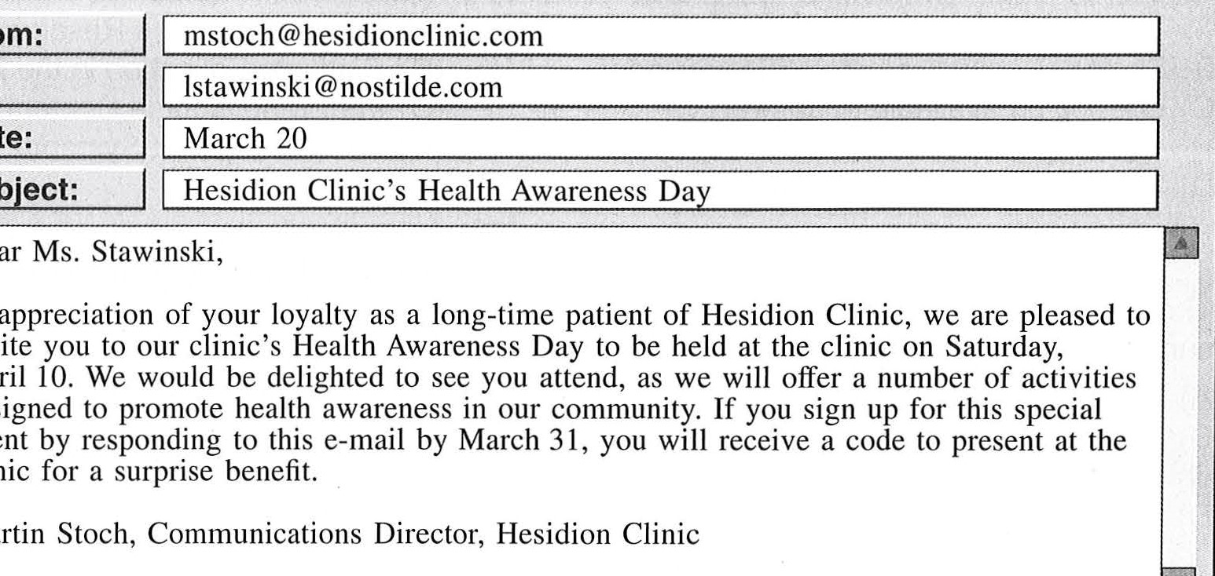
Dear Ms. Stawinski,
In
invite
April
designed
event
clinic
Martin Stoch, Communications Director, Hesidion Clinic
Hesidion Clinic Health Awareness bay, April 10
Tasks and Responsibilities
Communications: Martin Stoch
• Advertising: Adilene Walker
Presentations: Jillian Opala (Nutrition),
Lance Verhoeven (Fitness)
Kids' Health Game: Susan Hayashi
Health Checkups/ Talks: Anne Spillane,
Rami Al-Araj, Kurt Yin, Thierry baumas

Health Day at Hesidion Clinic by Shai Herzog on April 14
Hesidion Clinic hosted a successful Health Awareness Day this past Saturday. The event was held as a way to thank the community for supporting the clinic over the past 15 years. It was well attended by both Hesidion Clinic patients and members of the general public.
Attendees participated in a variety of presentations and everyone received free water bottles, notepads, and other items from event sponsors. Participants who provided a special code were offered a complimentary physical checkup from the team of clinic physicians.
During the event, a sizable line formed at Dr. Thierry Daumas' table. "I came out today to learn about skin care and advances in eye-care technology. But Dr. Daumas' talk about how to prevent cavities and improve
- What is Ms. Stawinski encouraged to do?
    - Complete a survey
    - Go to an event
    - Organize some activities
    - Meet with Mr. Stoch
- How did some attendees get a free health checkup?
    - By arriving when the clinic opened
    - By attending Dr. Daumas' talk
    - By responding to an e-mail from
Mr. Stoch
    - By winning a competition
- What does Dr. Daumas most likely specialize in? (A) Skin
    - Ears
    - Eyes
    - Teeth
oral health provided me with the most helpful information," said attendee Liana Stawinski.
By far the most popular event was nutritionist Jillian Opala's presentation on healthy eating habits. More than 100 people, many of them retirees, flocked to hear the latest on super foods. The event took nearly twice as long as expected, as Ms. Opala answered a steady stream of participant questions.
Children were delighted to take part in a health contest involving questions about general health and hygiene. The winners received toys and certificates from the game host. The day was such a success that Hesidion Clinic director, Lance Verhoeven, is already considering making it an annual event.
- What is indicated about the presentation on food?
    - It was filmed.
    - It was postponed.
    - It attracted a lot of attention.
    - It was given by a retired clinic employee.
- Who most likely distributed certificates?
    - Mr. Stoch
    - Ms. Hayashi
    - Ms. Spillane
    - Mr. Verhoeven

191-195 brochure, review, and e-mail.

STUDY BUSINESS IN SINGAPORE
The Singapore Business School (SBS) is located in the heart of Singapore's financial district. We offer a range of high-quality courses aimed at preparing students for graduate school. Between classroom sessions you can explore the city and cultivate business connections. We offer content-based classes, such as finance, economics, and international marketing, as well as classes on preparing graduate school applications, including developing CVs and writing personal statements.
We have helped thousands of students gain entry into graduate programmes around the world. We boast a number of high-profile part-time instructors who are experts in their fields, including Diara Rhodes, chief financial officer of Auto Drive Korea, and Farah Wan, vice president of the Kuala Lumpur Union Lenders. For more information about our impressive faculty and course offerings, or to enroll online, visit our Web site at www.sbs.edu.sg.
What Our Students Are Saying
3 June by Atsushi Koshi
I took a finance course at SBS. The school I am now attending in the United Kingdom had a prerequisite that I had not fulfilled while earning my Bachelor's degree, so the eight-week course was convenient. However, I couldn't afford the high rent in the area, so I had to commute, and the traffic in that area is terrible. I wish SBS offered a dormitory for students at the school. The quality of instruction was superb. My lecturer was Diara Rhodes. Though she tended to rush through lectures, discussing a wide range of topics in a small amount of time, I did learn a lot from the reading and from her descriptions of real-world experiences. The way she solved business problems was a source of inspiration during my graduate school interview, and it is also helping me in my current classes.

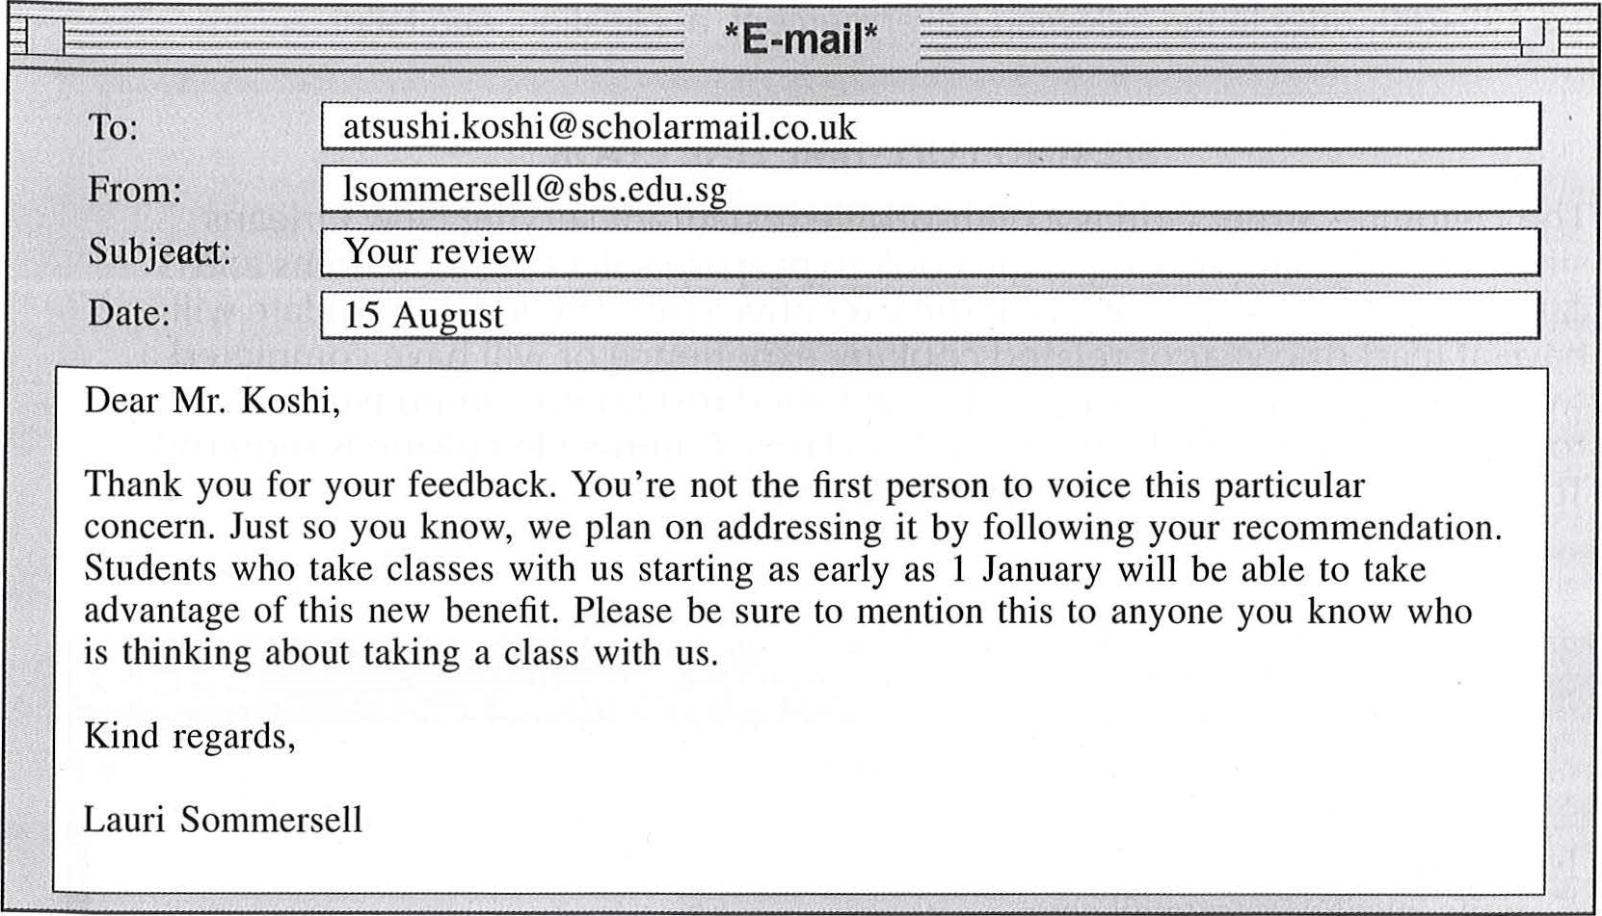
- Who is the brochure intended for?
  - Business professionals
(B) Potential graduate students
  - Instructors seeking employment
  - Aspiring writers
- What is indicated about SBS?
  - It is located in a busy area.
  - It offers financial assistance.
  - It provides internship opportunities.
  - It has employment-assistance services.
- What does Mr. Koshi mention about his lecturer?
  - She required a lot of reading.
  - She covered topics quickly.
  - She provided few examples.
  - She encouraged in-class participation.
- Where does Mr. Koshi's instructor work when she is not teaching?

(A) At SBS
- Ata bank in Singapore's financial district
- At Auto Drive Korea
- At Kuala Lumpur Union Lenders
195. How will SBS be addressing Mr. Koshi's complaint?
  - By hiring more faculty
  - By reducing the length of classes
  - By adding more transportation options
  - By building student housing on campus

196-200 advertisement, application, and letter.

SEEKING FULL-TIME LINE COOK
The Delphine Street Grill is a high-profile restaurant serving New Orleans since 1924. We are seeking a line cook to prepare select sautéed items and sauces under the supervision of the executive chef. The ideal candidate will have at least one year of related cooking experience or will have completed a two-year apprenticeship in a well-established restaurant. Demonstrated ability to prepare innovative dishes as well as classic Cajun-style cuisine is required. To apply, go to www.delphinestreetgrill.com/careers.

www.delphinestreetgrill.com/careers/line_cook/apply
Name: Anton Hoang
E-mail: antonh94@textmail.com
Phone: 504.555.0177
Related education: Associates degree in culinary arts, Boudreau Community College
Current employer/title: River Ferry Café, Line Cook Time employed: Six months
Previous employer/title: Hotel Lenoir, Apprentice Time employed: Two years
Previous employer/title: Picard Seafood, Intern Time employed: Three months
Résumé: Ø Attached
Reference list: IØ Attached
Cover letter:
I am very interested in the position of line cook at the Delphine Street Grill. For the past six months, I have been the line cook for a café serving traditional Cajun meals. Since the café has only recently been opened, I am responsible for preparing nearly all menu items. I completed my apprenticeship at the famous Hotel Lenoir, working side-by-side with Celebrity Chef Eugénie Mirone. In addition, as Ted Overbeck (my mentor and instructor at Boudreau Community College) can confirm, I am able to develop creative new recipes. In fact, while at the college, I was awarded the Excellence in Innovation Prize for a Vietnamese-style sandwich recipe I crafted, which is now on the menu at the college's cafeteria.
SUBMIT APPLICATION

198. Who is Mr. Overbeck?
- An executive chef
- An associate director

BOUDREAU COMMUNITY COLLEGE
School of Culinary Arts
Marie Beaumont
Delphine Street Grill
3248 Delphine Street New Orleans, LA 70117
Dear Ms. Beaumont:
I am writing in regard to Anton Hoang's application for employment. Since Mr. Overbeck is on leave this semester, he asked me to respond in his place. Mr. Hoang, who graduated in the top five of his class, demonstrated exceptional culinary skill and a strong desire to learn. He received a glowing review from Sabine Riou, the renowned chef who supervised his three-month internship. I am confident Mr. Hoang will be a valuable asset to your establishment.
Sincerely,
Fires
Liz Flores
Associate Director of Culinary Arts
196. What is indicated about the line cook | 199. What is suggested about Boudreau
position? | Community College?
(A) It is a two-year contract. | (A) It gives out culinary awards.
(B) It requires working the late-night shift. | (B) It offers free cooking workshops.
(C) It includes supervising the apprentices. | (C) It needs a new chef for its cafeteria.
(D) It involves preparing a limited variety of | (D) It invites celebrity chefs as guest
dishes. | speakers.
197. What is true about Mr. Hoang? | 200. Where does Ms. Riou most likely work?
(A) He is applying to work at several | (A) At the River Ferry Café
restaurants. | (B) At Hotel Lenoir
(B) He meets the requirements of the | (C) At Picard Seafood
position.  - He has appeared on television with Ms. Mirone.  - He taught at a culinary school in Vietnam. | (D) At the Delphine Street Grill
- A culinary teacher
- A restaurant owner

Stop! This is the end of the test. If you finish before time is called, you may go back to Parts 5, 6, and 7 and check your work.

